

**Bangladesh University of Business and Technology (BUBT)**

**Assignment on**

**Hybrid Solar**

**Course Code : ENG 111**

**Course Title : English Language II**

**Submitted to**

**Rifat Ara Shova**

Assistant Professor

Department of English

Bangladesh University of Business and Technology (**BUBT**)

**Submitted By**

**Name: Shanto Sikder**

**Full id: 20211203048**

**Intake: 37**

**Section: 01**

**Program/Dept:** **B.Sc. in CSE (Eve)**

**Date of Submission: 00/00/2021**

**Hybrid Solar power Systems**

Hybrid Solar Power System are [hybrid power](https://en.m.wikipedia.org/wiki/Hybrid_power) systems that combine solar power from a [photovoltaic system](https://en.m.wikipedia.org/wiki/Photovoltaic_system) with another power generating [energy source](https://en.m.wikipedia.org/wiki/Energy_source). A common type is a Power Hybrid System ] combining [photovoltaics](https://en.m.wikipedia.org/wiki/Photovoltaics) (PV) and [diesel generators](https://en.m.wikipedia.org/wiki/Diesel_generator), or diesel gensets, as PV has hardly any marginal cost and is t reated with priority on the [grid](https://en.m.wikipedia.org/wiki/Power_grid). The diesel gensets are used to constantly ﬁll in the gap between the present load and the actual generated power by the PV system.

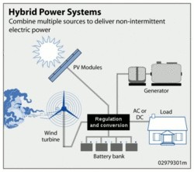

As solar energy is ﬂuctuating, and the generation capacity of the diesel genesets is limited to a certain range, it is often a viable option to include [battery storage](https://en.m.wikipedia.org/wiki/Rechargeable_battery) in order to optimize solar's contribution to the overall generation of the hybrid system.

In 2015, a case- study conducted in seven countries concluded that in all cases generating costs can be reduced by hybridising mini- grids and isolated grids. However, ﬁnancing costs for diesel- powered electricity grids with solar photovoltaics are crucial and largely depend on the ownership structure of the power plant.

While cost reductions for state- owned utilit ies can be signiﬁcant, the study also identiﬁed short- term economic beneﬁts to be insigniﬁcant or even negative for non- public utilit ies, such as [independent power producers](https://en.m.wikipedia.org/wiki/Independent_power_producer), given historical costs at

the t ime of the study

**Solar thermal hybrid systems:**

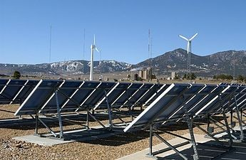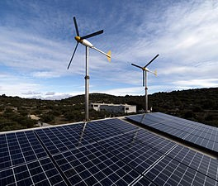Though [Solar PV](https://en.m.wikipedia.org/wiki/Photovoltaics) generates cheaper intermittent power during the day light t ime, it needs the support of sustainable power generation sources to provide round the clock power. [Solar thermal](https://en.m.wikipedia.org/wiki/Concentrated_solar_power) plants with thermal storage are clean [sustainable power generation](https://en.m.wikipedia.org/wiki/Load_following_power_plant) to supply electricity round the clock.

**See also:**

1.[Distributed generation](https://en.m.wikipedia.org/wiki/Distributed_generation)

2.[Hybrid power](https://en.m.wikipedia.org/wiki/Hybrid_power)

3. [Hybrid renewable energy system](https://en.m.wikipedia.org/wiki/Hybrid_renewable_energy_system)

4. [Photovoltaic thermal hybrid solar collector](https://en.m.wikipedia.org/wiki/Photovoltaic_thermal_hybrid_solar_collector)

**Source:** ["https://en.wikipedia.org/w/index.php?title=Solar_hybrid_power_systems&oldid=1022333 219"](%22https://en.wikipedia.org/w/index.php?title=Solar_hybrid_power_systems&oldid=1022333%20219%22)